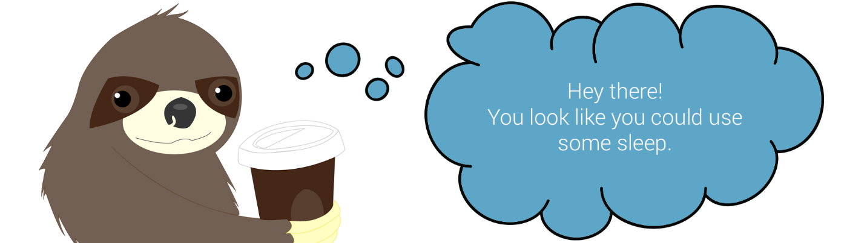

# **MDC 3rd semester – Project 3.2 – “Self-monitoring”**

**“Sleep advisor” – personal sleeping assistant**

**Online at: http://andreilazar.dk/sleepadvisor**

**Flinto prototype: http://www.flinto.com/p/d11f62bb**

# **Business Academy Aarhus**

# **27.10.2014**

# **Group members: Andrei Daniel Lazar, Livia-Marina Gherghe, Stefan Svetoslavov Marinov**

# **Supervisors: Bror Arnfast, Lars Bo Løfgreen, Morten Algy Bonderup, Peter K. Kristensen**

**Table of contents**

Introduction 2

Desk research 3

Relevant sleep statistics 3

Insomnia Treatment 4

Food, Drinks and Sleep 5

Music can aid sleeping 5

Reading a book 6

Screen brightness 6

Progressive relaxation processes 7

Similar apps/possible competitors 7

Field research 8

Notifications with Tips and Questions 10

Actual app functionality 11

Design process 12

Typography 12

The Colour Scheme 13

The Mascot 13

Iconography 14

Interaction 15

Conclusion 18

Reference list 18

Appendix 1 – Process 19

Appendix 2 – The Mascot 22

Appendix 3 – Final mockups 23

Appendix 4 – Sleep routine timelapses (part of field research) 24

# **Introduction**

The market for self-improvement/self-monitoring gear and apps is constantly evolving and people have already started to think about the way augmented reality, HUDs (head-up display), advanced GUIs (graphical user interface) and even artificial intelligence could help humans improve themselves (both mentally and physically) and how they live.

Transplants of artificial limbs and organs are already taking place. Further developments in medicine and neuroscience are taking place every day as well and we always get an insight into how our minds and bodies actually work and how strong the bond between them actually is. There are countless articles about “brain hacks” that use strange stimuli in order to trigger “special” abilities of our brains and quickly switch between emotional states.

There’s a whole lot of different takes on the subjects above in pop culture, particularly in literature and motion picture. From the Wachowski brothers’ “Matrix” trilogy and Stanley Kubrick’s “2001: A Space Odyssey” to the more recent Christopher Nolan’s “Inception” and Spike Jonze’s Academy Award-winning “Her”, all of them treat more or less the subject of self-improvement/self-monitoring. There’s also “Ender’s Game” to consider, a series of books that is being turned into feature films. Kids in *Ender's Game* are outfitted with monitors that oversee every aspect of their lives until they're removed by age 11. The monitors see through their eyes, and measure different areas of aptitude to judge who will be the best soldier. We usually think of this as a remote dystopian future, but we forget the fact that the devices that we currently use (which are continually developed) already have sensors that can track our behavior in all types of contexts and help us change/improve it.

Probably the biggest and “hottest” market segment right now consists of health tracking apps and accessories (especially smart bracelets/smart watches). A lot of big players such as Apple (with their brand new health app) and Razer (with the new “Nabu” smartband) recently jumped on the bandwagon. The already established smartband brands such as Jawbone, Misfit and Fitbit managed to attract and satisfy a lot of customers with their easy-to-use features and device compatibility. They all had a well-established plan and they’re succeeding at it: tracking a user’s everyday behavior and health statistics, thus helping him improve his overall mental and physical health.

While the smartbands and smart watches are slowly but surely taking control over the market, there seem to be less and less apps that don’t actually require an external accessory in order to help you track data from your everyday life and subsequently achieve your goals.

There are countless apps regarding sleep tracking on both Google Play and Apple Store, but most of them lack the user interactivity that popular apps from other market segments have. In our opinion, this affects the actual “impact” the app has on the user’s everyday life. If an app is easy-to-use, playful and practical at the same time, chances are people are going to use it more often and take into account the way that specific app is trying to help them. If not, then they try to jump to alternatives or just completely forget about the whole point and get back to their comfort zone - the usual “fun” apps. At the end of the day, no one really uses apps that seem “linear” anymore.

The main problem with the other sleep apps is the fact that the user is not able to interpret the gathered data in an easy manner and there are no tips or notifications of any sort. Basically, the apps are providing sleep statistics, charts, they offer alarms, gentle alarms and some of them even have tabs with sleep tips. But they don’t provide updated information, tips or notifications based on your usual sleep/work/workout schedule, they don’t adapt to your needs and they don’t act as an “assistant”, but more as an “angry maths teacher”.

This led us to our problem statement: How can we combine practicality and fun into an application that would help users engage in and maintain a healthy sleep behaviour, especially the ones that have an extremely busy schedule and the ones that suffer from insomnia or sleep disorders?

# **Desk research**

## **Relevant sleep statistics**

We’re going to give you an insight into our process of finding studies and information relevant to our application concept by offering you the following four quotes:

“*Before Thomas Edison invented the light bulb, people slept an average of 10 hours a night; today Americans average 6.9 hours of sleep on weeknights and 7.5 hours per night on weekends.* ” [1]

“*Sleep deprivation and sleep disorders are estimated to cost Americans over $100 billion annually in lost productivity, medical expenses, sick leave, and property and environmental damage.* ” [2]

*“While many Americans enjoy the benefits of sufficient sleep, as many as 47 million adults may be putting themselves at risk for injury, health and behavior problems because they aren’t meeting their minimum sleep need in order to be fully alert the next day. ” [3]*

“*The National Highway Traffic Safety Administration conservatively estimates that 100,000 police-reported crashes are caused by drowsy drivers each year. (That is about 1.5% of all crashes.) These crashes result in more than 1,500 fatalities and 71,000 injuries and result in an estimated $12.5 billion in diminished productivity and property loss.* ” [4]

Moreover, according to a survey conducted in the first quarter of the year 2014 with a sample of statistically representative US adults above 18 years of age, sleep loss may or may not be self-inflicted, but the lack of adapting to a healthy sleep routine is behaviour-dependant.

Most Americans have shared that they find having an extra hour of sleep at night very valuable. Males and adults under the age of 55 do not find the extra hour of sleep as valuable as females and in general adults above the age of 55.

Around 50% of the surveyed sample of Americans have reported they do not get enough sleep per night. The amount of people with chronic insomnia is around 60 percent of the surveyed sample.

Another survey shows that around 34 percent of all people in the world (one in three adults) suffer from some form of sleep deprivation.

Last but not least, the most important fact we were aiming for and have eventually discovered during our desk research is the following: According to Morin CM, Colecchi C, Stone J, Sood R and Brink D, who conducted a peer-reviewed study comparing medication and behavioral therapies for insomnia, sleep improvements are better sustained over time with behavioral treatment rather than pharmacological approaches.[5]

A lot of other useful in-depth statistics that helped us throughout the creative process can be found in “The Sleep SolutionWorkbook by G. Frank Lawlis, Ph.D.”.

**Insomnia Treatment**

First, in order to see what kind of treatment is necessary for insomnia, every person should check whether they have an underlying medical conditions or not, because if those are cured, chances are that the insomnia is going to disappear.

For **short term insomnia**, there are methods that should help people solve it, such as having a fixed time for going to sleep and waking up, sleeping in a dark and quiet room, avoiding caffeine, nicotine, heavy meals and alcohol late at night, not doing physical exercise unless it’s related to breathing (such as yoga and t’ai chi). All these constitute what is called “a good sleep hygiene”.

An alternative that could help ease this type of insomnia is the doctors prescribing sleeping tablets (hypnotics). However, it is recommended that they aren’t used over long periods of time, because they don’t actually solve the problem.

For **long term insomnia**, which lasts more than 4 weeks, a solution is cognitive and behavioural therapy, which should help the patient change unhelpful thoughts and behaviours in such a way that they can eliminate insomnia. With the help of a specially trained GP, the patient can practice: stimulus-control therapy, sleep restriction therapy, relaxation training, paradoxical intention and biofeedback. In case this doesn’t work, hypnotics, antidepressants, and medicine based on melatonin could be prescribed by a medic. [6]

For those who want to prevent or reduce insomnia, or just fix their sleeping schedule, our app would be useful, because not only would it track their sleeping patterns, but also eating habits and the distance that they travel on foot. Based on these, the users receive notifications on their phones that remind them of shaping their habits properly so they can gain more energy  and be more productive during the day.

**Food, Drinks and Sleep**

A reason for not being able to sleep properly is the consumption of food that is hard to digest, as the digestive system is supposed to be resting between 7pm and 5am, so in case someone eats, for example, spicy food, their digestive organs have to work overtime.

Beverages that contain caffeine (such as coffee, tea and soda) should not be consumed for four to six hours before going to bed. Alcohol is to be avoided as well for around 3 hours prior to bedtime, because although it helps a person fall asleep faster, it is also a cause for restlessness during sleep.

While it is advised to not eat a lot before bedtime, a light snack could be useful, as long as it contains tryptophan, an amino acid component that helps the body produce serotonin, a neurotransmitter that induces sleepiness. Some foods that contain tryptophan are: oatmeal, vegetables, seeds, poultry, dairy products, pork, beef and seafood.

The Sleep Advisor app is going to give the users some tips regarding food and drinks based on the day period and place they’re at, if they tick the meal times and geolocation options in the menu. They’ll also be asked whether they ate, or if they are going to eat in a certain amount of time.

For example, if a person goes grocery shopping in the evening, the app will know that they’re in a shop with the help of geolocation and send a notification with some of the food products that could help with sleep.

This will help them regulate their eating schedules, and also build up a better sleeping hygiene.

**Music can aid sleeping**

Several research experiments regarding music and sleep have been conducted along the years and they concluded something: people with sleeping disorders can have a more peaceful sleep if they listen for about 45 minutes to music or sounds that have a tempo between 60 and 80 BPM (beats per minute) before bedtime. Most of the researchers used classical songs on their test subjects, but any piece with the tempo mentioned above should work.

Although music with slow tempos may help people with sleeping problems, it does not have the same effect for those who already have a restful sleep.

According to statbank.dk, in 2012, 52% of Danish people said that they listen to music when they want to relax, most of them preferring pop music the most (76%), followed by rock music (53%) and classical music (32%). Most pop and rock music has a tempo of over 100 BPM, while classical music tends to have less.

In the same year, 38% of Danish people said that they listen to the radio as a way of relaxation, while 69% have it in the background when they’re taking care of practical things at home, so it’s clear that this wouldn’t help them sleep.

**Reading a book**

A wide variety of people that are suffering from sleeping disorders have tried reading a book before going to bed in the evening. According to a survey conducted by the Danish government 58 percent of the given sample of people with sleeping problems have tried and/or are still reading books as a means of falling asleep more easily. There are a lot of different ways for one to entertain him/her-self with a book and the surveyed people have given information on their preferences. Around 80 percent of people prefer reading printed paper books, as opposed to the 8 percent who prefer reading books on electronic devices, such as e-book readers, computers, tablets etc. Surprisingly, the people who are used to listening to audio books instead of reading books are 10 percent.

The majority of people (~76 percent of the sample of people) prefer sitting down in order to read a book and be comfortable while doing it. People tend to read books more when they have more free time so holidays are the time when they like spending more time reading (~66 percent of the sample of people read more on holidays).

And finally, around 60 percent of the sample of people read mostly books for information and to gain knowledge about something they are interested in.

**Screen brightness**

According to a large amount of studies the screen brightness affects the ability to easily fall asleep. Therefore, the use of apps and/or programs which dim the brightness and lower the contrast of the screen has been made popular. Programs for the PCs such as Flux can dim your screen automatically depending on the time of day, decreasing the awareness of the brain and, therefore, helping with falling asleep.

Similar apps are being developed for mobile users. One of highly popular ones is called Twilight. People nowadays use mobile phones and tablets during the whole day and late at night as well, while the light emitted from these devices keeps their brains constantly aware and, therefore, an app that dims the light of the screen automatically would definately find use in the everyday life of most users.

**Progressive relaxation processes**

These techniques involve tensing specific muscle groups and then relaxing them to create awareness of tension and relaxation. They focus on all the major muscle groups and the key principle is the fact that the individual that practices these has to try to relax a specific body part at a time, starting either with the feet or forehead. Progressive relaxation techniques can be combined with breathing exercises, resulting in an even more complete approach in terms of achieving the perfect body and mind state.

**Similar apps/possible competitors**

Below are some screenshots from the most popular sleep monitoring apps on Google Play:

**Figure 1 – Sleep Analyzer**

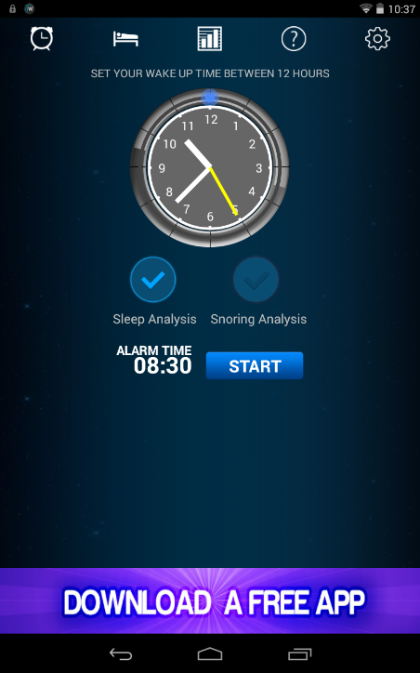 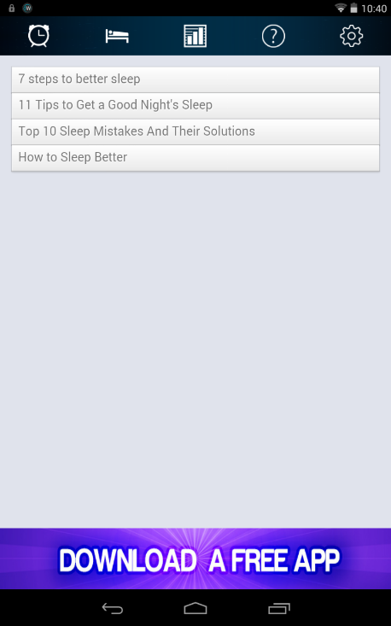 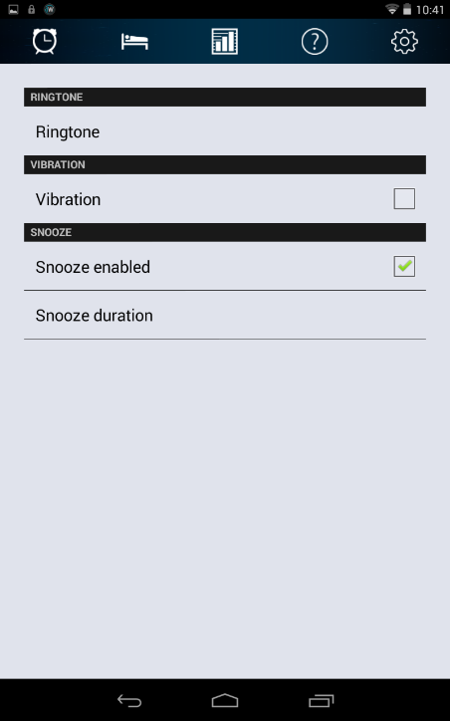

First of the images above represents the starting screen of “Sleep Analyzer”, which basically offers the user only two options: “Sleep Analysis” and “Snoring Analysis”. The user can set a start time for the sleep/snoring tracking and a trigger time for the alarm and… that’s pretty much everything he can do. The other tabs in the images above are the “Help” and the “Settings” tabs. The “Help” tab contains different kinds of links to articles with tips for a better sleep, while the “Settings” tab allows the user to change the ringtone, to activate/deactivate vibration and to enable or disable snooze. That’s something even a basic alarm clock from the 90s can do.

The only difference between an alarm clock from the 90s and a sleep tracking app from 2014 is basically the fact that the app offers you an overview of how much you slept every day, while in the 90s you had to write that down every day on a notebook. Somehow amusing, right?

**Figure 2 – SleepBot**

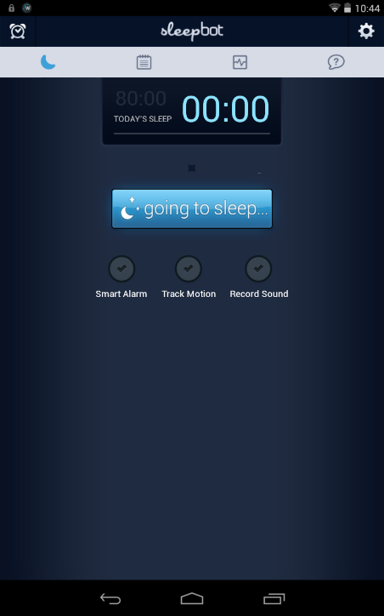 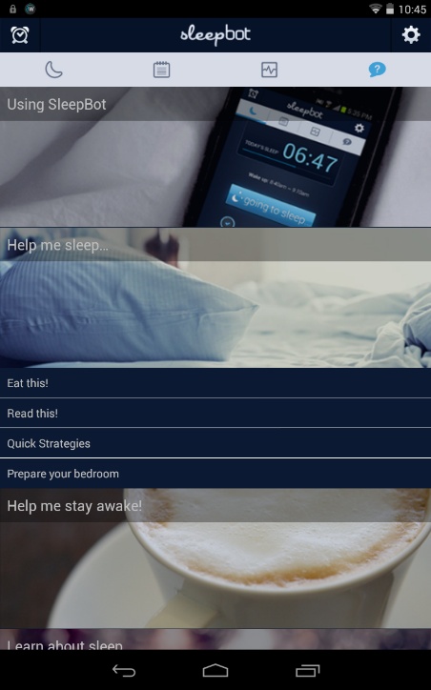 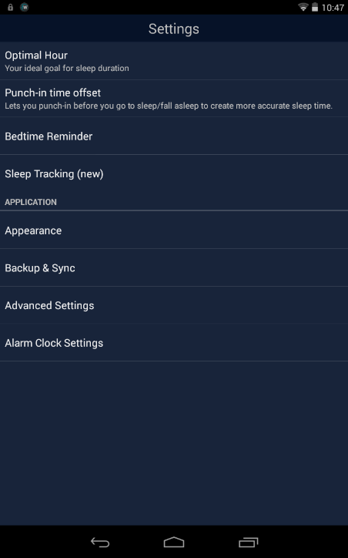

What we have written about “Sleep Analyzer” goes for “SleepBot” as well, except the latter offers a wider range of new features such as motion tracking or bedtime reminder. That’s much better than “Sleep Analyzer” and most of the other relevant apps on the market, but still nowhere close to what mobile devices can potentially offer in terms of user experience.

The sleep advisor app we have been working on is quite different from the other relevant competitors on the market because of the fact that it provides useful, fun and practical tips by sending notifications to the user based on the gathered data throughout a certain timespan.

# **Field research**

Throughout the first week of working on Project 3.2 we tried to get to know an average person's sleep routine better. Desk research and help from the school's library helped us find critical information about insomnia, sleep disorders, a certain environment's impact on sleep depending on the intensity of the light and sound, how laptops and other devices' screen brightness affect the user's behaviour before sleep and possible solutions for the aforementioned.

We needed to do some research that was more practical and that could actually give us a better insight into the problem itself (individuals that need advice on how to set up and follow a tight sleep schedule for a better and healthy sleep) and how our app was going to solve it, so we  decided to monitor our sleep cycles every night since the beginning of the project with three different sleep monitoring apps on Google Play (each of us picked one). Not only did this help us towards getting to know "the ideal behaviour" when it comes to sleep, but it also pinpointed the weaknesses of sleep monitoring apps.

Below is some of the data we gathered.

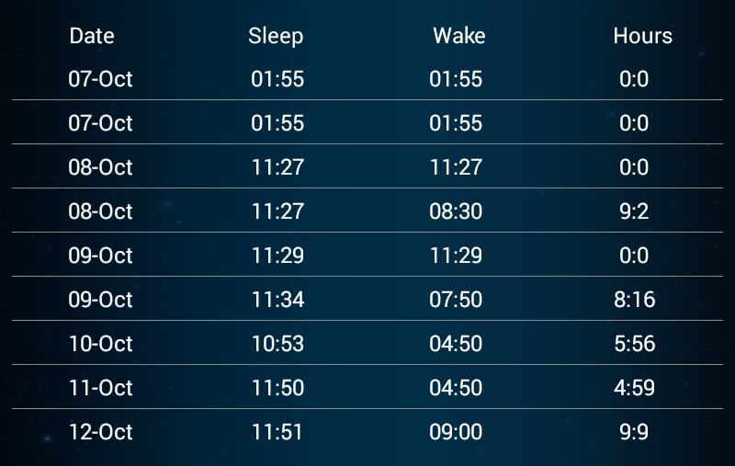Marina – SleepBot Andrew - SleepAnalyzer

|  |  |  |  |
| --- | --- | --- | --- |
| Date | Sleep Time | Awake Time | Duration |
| 10-15-2014 | 00:54 | 08:10 | 07 hr 16 min |
| 10-14-2014 | 02:01 | 09:45 | 07 hr 44 min |
| 10-13-2014 | 02:17 | 08:22 | 06 hr 05 min |
| 10-12-2014 | 04:23 | 10:30 | 06 hr 07 min |
| 10-11-2014 | 01:21 | 10:30 | 09 hr 09 min |
| 10-10-2014 | 01:05 | 08:35 | 07 hr 30 min |
| 10-09-2014 | 00:11 | 08:35 | 08 hr 24 min |

SleepBot is overall better than SleepAnalyzer when it comes to the amount of options available for the users and the level of “customizability”. SleepAnalyzer doesn’t allow you to edit or change the monitored sleep hours in any way. This means, for instance, that you’re going to have irrelevant data such as the “0:0” sleep hours above if you’re going to start and stop the monitoring by accidental tapping of the screen.

Besides tracking our behaviour during the project with the sleep monitoring apps on Google Play, we also tried to focus on constantly taking notes, not only of what we've been doing every night during the last couple of hours before falling asleep, but actually also of our activity long before going to bed and, by comparing our data to the desk research statistics, accurately describe an average person's routine before going to bed, thus trying to identify the most common (and easily fixable) mistakes people tend to make when it comes to maintaining a good sleep schedule.

Here's a list of common mistakes people make before going to bed that affect sleep quality:

* Listening to loud music or tracks with high BPM (beats per minute).
* Eating right before going to bed.
* Talking to friends on Skype or any other video or text messaging service.
* Playing video games.
* Engaging in different kinds of challenging or chaotic reading.
* Not letting enough fresh air into the room.
* Consuming caffeine, sugar or alcohol.
* Falling asleep with the TV on.

There's also a list of common mistakes people make throughout the day that affect their sleep quality:

* Hitting the "Snooze" button in the morning.
* Inappropriate work ethic.
* Bad nutrition.
* Inappropriate gym time/working out too often.

We're no doctors, dieticians, neurologists and so on, but we believe we've done enough research to come to the conclusion that the habit of healthy sleeping can be achieved not only through self-monitoring and/or sleep monitoring, but through self-monitoring, data interpretation, personal assistance and biofeedback.

Out of our group members, the one that seemed to struggle the most with sleeping at least 7 hours per night was Stefan. After checking his sleep environment, his sleep monitoring data and his usual schedule before going to bed, we eventually came to the conclusion that the possible cause for his sleep deprivation is either cardiac insuficiency or hypertiroidism (or both).

Even though we didn’t manage to integrate scientifically proven cures for these within our app, we had the option of working on Stefan’s overall attitude towards a better sleep hygiene and try to change it, which helped a lot. Probably much more than any pharmacological approaches.

At the end of the day, the most effective way of getting more and better sleep every day is behavioral change.

How exactly?

# **Notifications with Tips and Questions**

Based on the place where they are, the users are going to receive notifications with tips about food, beverages, physical exercise and other general info. Here’s the list with some examples of tips and questions for some of the categories:

1. Meal times:

If you're at your workplace's/school's canteen, the app is going to recommend you food that contains ingredients which would help you have a better rest at night time.

For each important meal of the day, the notification will ask: “Did you eat breakfast / lunch / dinner?”. If not, there will be another question with “Are you going to eat in the following 30 minutes?” and if you’re going to answer “Yes” (swipe right), then the sloth is going to be happy that you’re taking care of yourself and tell you what you could eat for the respective time of the day. If you say that you won’t eat (swipe left), the sloth is going to be sad and remember you skipped a meal.

2. Grocery stores:

If the user goes grocery shopping in the evening, a notification will pop up: the sloth is going to hold a glass of milk in its hands and it will say something like “Hey buddy, it’s late. You could buy some vegetables for dinner...” (or other foods that have tryptophan in them) or

3. Restaurants:

When people go to restaurants 6 hours before their bedtime, they receive a notification saying “Pal, be sure to keep your caffeine levels low!” and then a cup of coffee encircled by a ban sign appears. In case the user denies the notification, a tip with "Hey, buddy. You promised you would do yourself a favour, so try avoiding coffee at this time of the day, would you?". If you swipe right, the advisor is going to reply: "You rock, champ."

4.  The gym:

Let's say you're planning on heading to the gym after 7 p.m. and your usual bed time is around 10 p.m. The sloth is going to gently remind you that you shouldn't workout within the last 3 hours before going to sleep:

“Yo, did you know that it’s better not to strain your body 4 hours before sleep?” and then “Try some yoga or t’ai chi, if you want to relax by exercising. ”

5. Bars:

If you go out to some pubs/bars drinking with your friends during the weekend, the morning after the app is going to advise you concerning your possible hangover and the way you can get a better sleep afterwards.

6. Steps counter:

If you walk a lot on a certain day, let’s say, for example, 5000 steps, in the evening the sloth is going to be sleepy and advise you to drink some milk and try to sleep more, because you must be very tired.

# **Actual app functionality**

The sleep advisor app takes some features that are already existing in similar apps (such as the basic sleep monitoring), but it is definately a game changer because of the new characteristics it has, one of them being the fact that it tries to find out how tired the user is and “help” him by determining how much he walked and whether or not he skipped a meal during a certain day.

The app offers different options that can be enabled: meal tips, location-based tips, auto sleep mode at bedtime hours, bedtime reminders, sleep tracking and steps counter. They are, of course, fully customizable, so you can enable or disable certain features at any time, but the more are active at the same time the better. They all store data which ultimately leads to better tips for the user.

The “Input new data” button on the main page allows the user to enter his/her updated data at any time. The user can input his usual meal hours so the app is going to be able to send practical and well-timed advice (by enabling “Meal tips” as well) against eating certain products or skipping meals, while also asking for feedback. Other than that, the user can also input different bedtime hours, the daily amount of sleep he’s trying to “achieve” and existing medical conditions. Moreover, if he doesn’t like getting notifications in certain places, he can add them to the “Exclude places” list.

The "Auto sleep mode at night" refers to the option of automatically turning on the app’s features strictly related to sleep (whenever the usual bedtime interval arrives): turning off the device’s sound and the blinking notification light at night, turning on the sleep tracking and reducing the screen’s brightness. We have also discussed about adding the option of automatically turning off the PC to this mode, considering the fact that the user might be in bed and he would love to be able to create a perfect sleeping environment with just one tap. It is definitely doable[7] but we didn’t manage to fiind the right source code and work on it.

“Sleep tracking” is the feature that monitors the user’s slept hours and the quality of his/her sleep, by motion tracking and sound detection.

"Location-based tips", “Bedtime reminders” and "Steps counter" are pretty much self-explanatory.

“Auto sleep mode” can be enabled at all times or manually activated during a certain night by tapping on the “I’m going to sleep” button.

The app gathers data (sleep monitoring/steps counter) which can be seen by tapping on “See your stats >”. If a user wants to have permanent access to the data gathered by the sleep advisor, he needs to create an account.

When the user opens the app for the first time, the sleep advisor asks him/her to input a few details about his/her daily routine, such as usual bedtime and wake up time, usual meal intervals and most visited places.

The app is going to use this data to accurately provide further notifications related to the user's sleep hygiene.

Last but not least, there’s another button on the app’s main page: “I need advice”. The user can tap on it if he’s not satisfied with the random notifications and he wants to receive a tip right at that specific moment in time.

# **Design process**

**Typography**

We have been searching for fonts often used in the interfaces of mobile apps and we stumbled upon ”TheSans”, ”Trajan” and ”Helvetica”, but these are quite overused so we eventually decided to look for inspiration elsewhere.

And we ended up using ”Roboto” (more particularly, ”Roboto Thin”), which is the font Google uses to promote its ”Nexus” line of products. See the typo below:

Grumpy wizards make toxic brew.

0123456789

**The Colour Scheme**

After checking different sources and taking into account the ways colours affect sleep, we picked and modified a palette which was submitted to Adobe Color CC on 18/10/2010, which consists of the colours below.

   

RGB 48 37 54 RGB 72 54 82 RGB 52 87 104 RGB 94 166 199

A study from a hotel booking site called Travelodge was the source that influenced us the most into selecting a color scheme which mainly consists of smooth shades of blue and dark purple.

According to that study, British people who sleep in a blue bedroom got the most sleep (an average of 7 hours and 52 minutes every night) because this color is associated with calmness and it is also supposed to help reduce blood pressure and heart rate.

The study gives more colors to choose from, such as yellow, green, silver and orange, but trying to mix them in the same UI did not really bear the expected results, as the users’ eyes would have to strain in order to read the text.

However, a lot of commenters complained that the study is irrelevant because most people choose a wall color based on their personalities and it usually doesn’t affect their sleep hours, since they don’t keep their lights on and can’t see colors in the dark.

So for the background, we chose dark purple because it is very friendly to the eyes, especially in the dark, and it also lets you read blue text without any problems. Also, one of the commenters said that purple walls helped them have a better sleep, while yellow, the 2nd best color (according to a Travelodge study) was the cause of reccuring nightmares.

**The Mascot**

We thought this kind of app would eventually become too boring if it kept on spamming text without any animations or images at all. In general, funny visual elements, especially cartoon characters, make people more eager to use an app because “it’s cute, amusing and it often makes them smile”.

So, we decided to create a mascot that would go along well with our concept and that is often associated with the idea of sleepiness in popular culture: a sloth. Why a sloth?

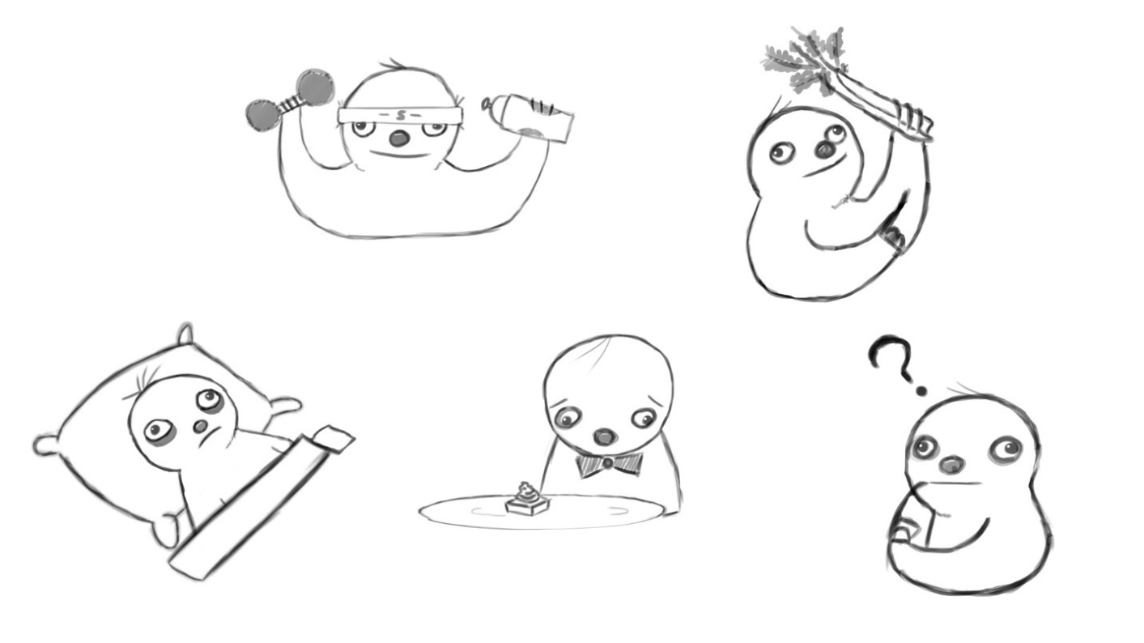

Because they seem lazy, move slowly and most people think that they all sleep 16 hours a day or more, when, in fact, they are closer to the human ratio, getting around 10 hours of rest daily if they are not kept in captivity[8].

Therefore, it would be good to take advantage of what people think they know about this animal in order to make them feel that “If a sloth can sleep so much, then so can I.”. We have to make the users get attached to the app and inserting a friendly mascot that gives tips and asks for feedback seems to be the most efficient approach to stimulate a person in developing a better sleep hygiene and even defeat insomnia or any disorders they’re struggling with.

**Iconography**

Even though we haven’t managed to code that much of our application in Eclipse, we still thought about the app’s icon and Google Play features. The icon set can be seen below.

 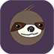 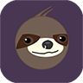 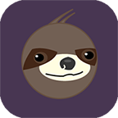 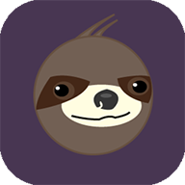

MDPI HDPI XHDPI XXHDPI XXXHDPI

# **Interaction**

**Tools of the trade:**

We found out that a lot of Android apps are actually made with the help of web development languages such as HTML, CSS, PHP, Javascript, jQuery etc. and not necessarily in Java. So, being more skilled in web development, we’ve coded a non-native prototype for Sleep Advisor and we made it open the links directly into the app without the need of a browser. How is it possible?

Eclipse, the Java development tool we currently use, supports Android apps development and it has a pretty useful layout for pages written in web languages: the WebView.

**Demos:**

Originally, we planned on changing the dots' color and making the font thicker (highlighting) when the user clicked on it. The code for that looks like this:

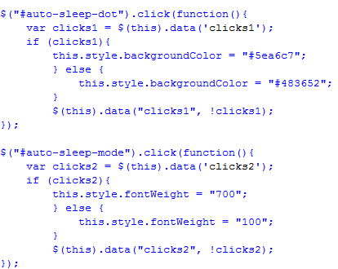

But we have decided that since this is a prototype, we're going to use jQuery alerts to demonstrate how the app would work. Usually, alerts are used in case of errors, but we took the liberty to use them as notifications that the users receive when they tap on an option in the app’s main menu.

The design of the original alert is too boring, so we used SweetAlert instead, an opensource jQuery plugin that beautifies the aspect of the message box and seems friendlier.

You can even add images to it.

Example:

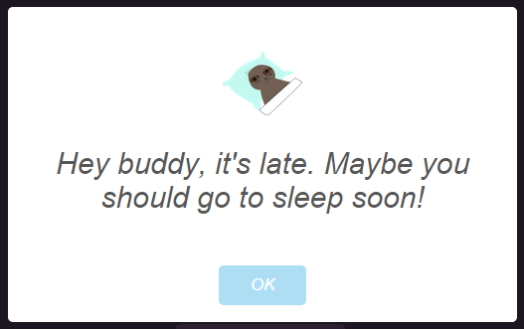

Due to increased ease in the development stage of the registration and login page the team has decided to work with XML, as opposed to using MySQL which the team has limited knowledge in.

$errors = array();

if(isset($_POST['login'])){

$username = preg_replace('/[^A-Za-z]/', '', $_POST['username']);

$email = $_POST['email'];

$password = $_POST['password'];

$c_password = $_POST['c_password'];

if(count($errors) == 0){

   $xml = new SimpleXMLElement('<user></user>');

   $xml->addChild('password', md5($password));

   $xml->addChild('email', $email);

   $xml->asXML('users/' . $username . '.xml');

   header('Location: login.php');

   die;

}

}

The previously shown code snippet is a part of the functions responsible for creating and saving a user with a username, e-mail and password in a unique file that takes the place of a database on the web server the website resides on.

$error = false;

if(isset($_POST['login'])){

$username = preg_replace('/[^A-Za-z]/', '', $_POST['username']);

$password = md5($_POST['password']);

if(file_exists('users/' . $username . '.xml')){

$xml = new SimpleXMLElement('users/' . $username . '.xml', 0, true);

if($password == $xml->password){

session_start();

$_SESSION['usergroup'] = 'employees';

$_SESSION['username'] = $username;

header('Location: userInputs.php');

die;

}

}

$error = true;

The previously shown code snippet is used to determine whether the inputted username exists and if it so does, it compares the inputted password with the one corresponding to the inputted username. However, if the username check happens to fail, a text message declaring the peccability of the inputted username and/or password gets displayed on the screen.

**Databases and tables:**

We’ve used our knowledge of creating a database with tables that contain information regarding the activity that the user wants tracked. Thus, we’ve got a database called “hiperstyle_database” and 2 tables called “sleepbot” and “moves” so that the users can see how much they slept and how many steps they took in certain days.

To create our database in SQL, we wrote:

CREATE DATABASE hiperstyle_database;

To create the tables, we used:

CREATE TABLE sleepbot (

Date date not null,

Sleep time not null,

Awake time not null,

Duration time not null

);

and

CREATE TABLE moves(

Date date not null,

Steps mediumint not null

);

Date, Sleep, Awake, Duration and Steps are the titles of the tables’ columns; date, time and mediumint are the formats that the columns can accept; not null means that the rows of the respective columns can’t be empty when new information is added to the tables.

# **Conclusion**

Right from the very beginning of the project we have been thinking about the possibility of developing some sort of personal assistant that can gather data about the user and make useful suggestions based on it. We were initially relying on the concept of dream interpretation but we wanted to work on something practical and efficient and that proved to be a bit too tricky in terms of adapting the whole idea to an app interface. Therefore we were forced to expand our horizon and look into similar fields and eventually got to the act of sleeping and its importance in a human's life.  
  
Through our brainstorming sessions and research we managed to gather crucial info and turn it into the sleep advisor's essential features. We believe that proper self-monitoring data interpretation is an essential aspect that many developers and big companies tend to neglect.   
  
We used to think better sleep can be achieved through behavioral change. Now we're firmly sure of it. And so is our sloth.

# **Reference list**

Publications / important references:

* “A joint publication of the Sleep Research Society and the American Academy of Sleep Medicine” - http://www.journalsleep.org/
* “National Sleep Foundation” - http://sleepfoundation.org/
* G. Frank Lawlis, Ph.D. - “The Sleep SolutionWorkbook”
* Wroblewski - “Mobile First”, chapters 1-3
* McFarland, DS (2012). JavaScript &jQuery: the missing manual. 2. ed. US: O’reilly Media;
* Castro E, Hyslop B (2012). HTML and CSS3. 7. ed. CA: Peachpit Press;
* Ullman L (2011). PHP for the web. 4. ed. US: Peachpit Press;

Research links:

* http://developer.android.com/guide/topics/ui/notifiers/notifications.html
* http://www.theguardian.com/lifeandstyle/2011/jan/29/how-to-improve-your-sleep
* https://justgetflux.com/research.html
* http://sleepyti.me/
* http://www.reddit.com/r/Fitness/comments/2dh634/would_rfitness_be_interested_in_a_post_about/
* http://www.journalsleep.org/ViewAbstract.aspx?pid=28247
* http://www.sleepeducation.com/news/2014/03/10/insomnia-awareness-day-facts-and-stats
* http://sleepeducation.com/sleep-disorders/insomnia/treatment (cognitive behaviour therapy and other treatments)
* http://www.rightdiagnosis.com/i/insomnia/stats-country.htm (statistics by country) http://www.rightdiagnosis.com/i/insomnia/treatments.htm (t'ai chi is mentioned)
* http://en.wikipedia.org/wiki/T'ai_chi_ch'uan (info about t'ai chi)
* http://en.wikipedia.org/wiki/List_of_t%27ai_chi_ch%27uan_forms (moves that a person can do in t'ai chi)
* http://www.cdc.gov/nchs/data/databriefs/db127.htm (statistics)
* http://www.huffingtonpost.com/kellie-edwards/what-is-mindfulness-10-an_b_5903984.html (mindfulness)
* http://www.sciencedaily.com/releases/2010/09/100915140336.htm (aerobic exercise)
* http://sleepfoundation.org/ask-the-expert/how-does-exercise-help-those-chronic-insomnia (what beneficial changes exercising brings)
* http://www.theguardian.com/lifeandstyle/2012/nov/04/how-to-beat-insomnia (sleep hygiene)
* http://www.azumio.com/how-food-affects-sleep-tips/ (food info)
* http://news.bbc.co.uk/2/hi/health/4228707.stm (the effect of calm music)
* http://wellness.pittsburghsymphony.org/can-music-help-you-get-a-good-nights-sleep/ (music again)
* http://www.tandfonline.com/doi/abs/10.1080/08098131.2013.783095#.VDZ6q_mSzHR (the NON-influence of music for people without sleeping problems)
* http://health.usnews.com/health-news/blogs/eat-run/2013/02/26/how-too-little-sleep-affects-how-we-eat
* http://www.reddit.com/r/explainlikeimfive/comments/1lh572/elif_what_happens_to_the_brain_during_sleep/
* http://readwrite.com/2014/10/02/apple-health-app

Inspired by: Ping (http://iamping.com/);

Moves (https://www.moves-app.com/);

SleepBot (https://mysleepbot.com/).

# **Appendix 1 – Process**

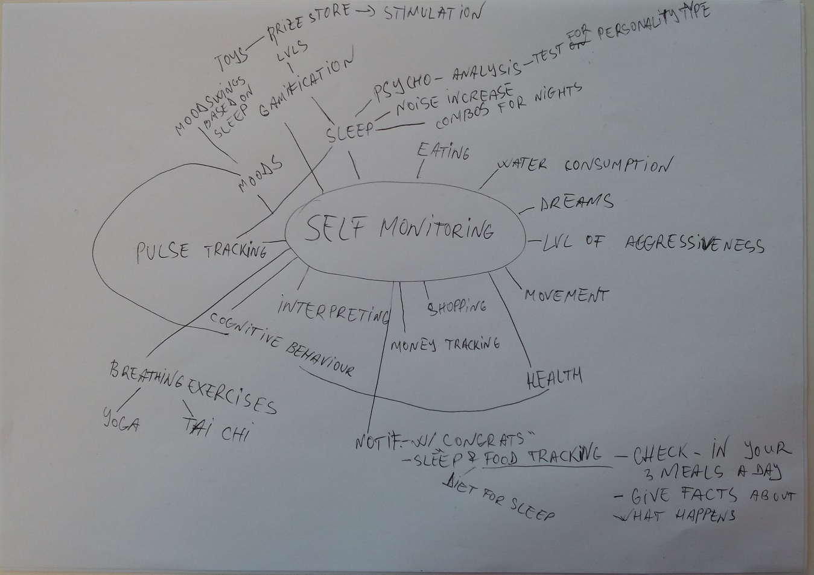

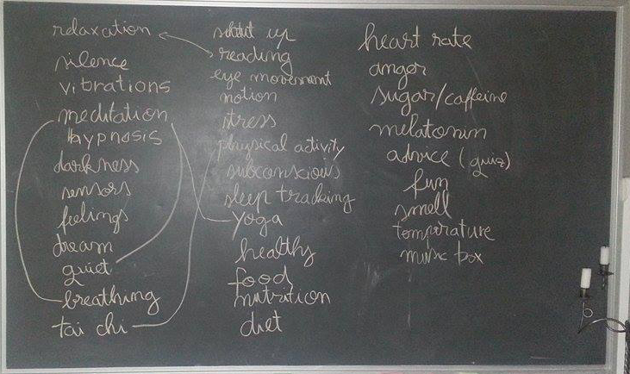

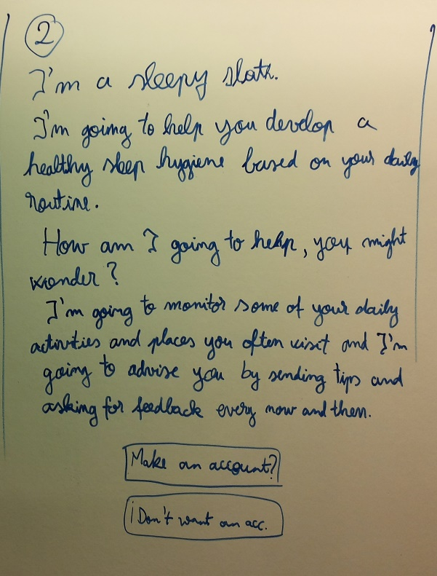 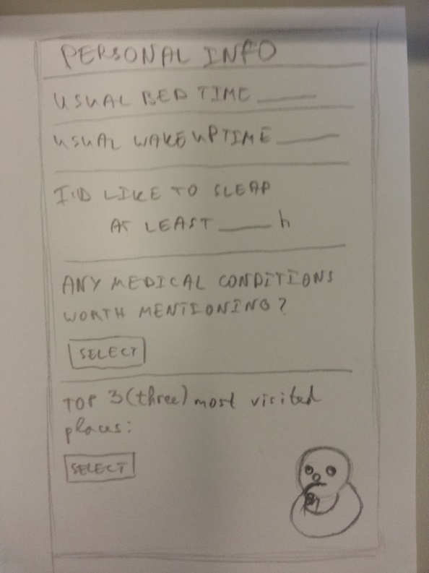

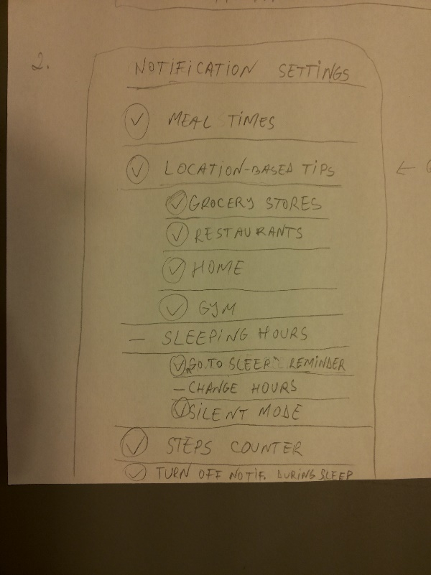 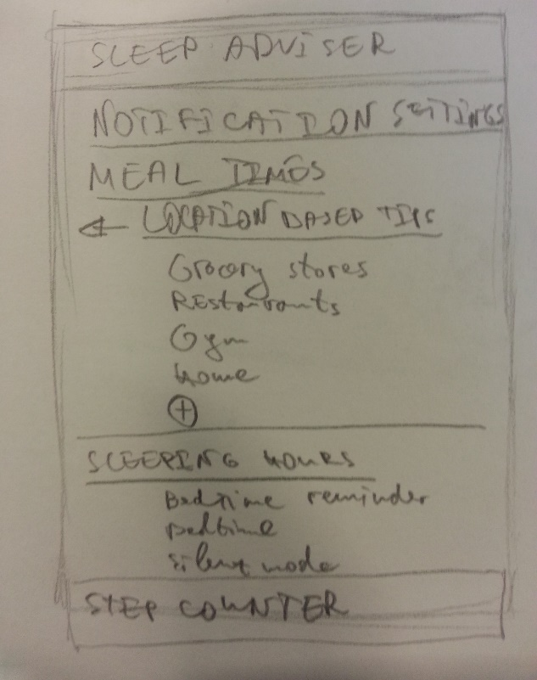

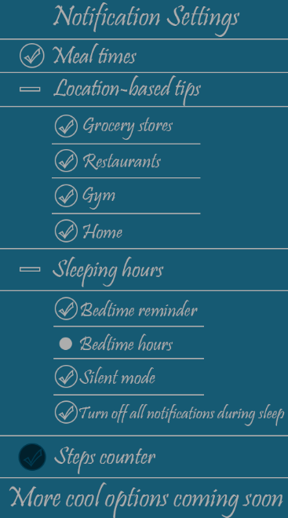 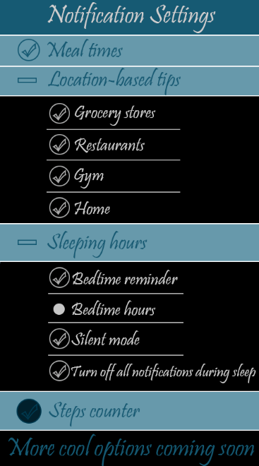 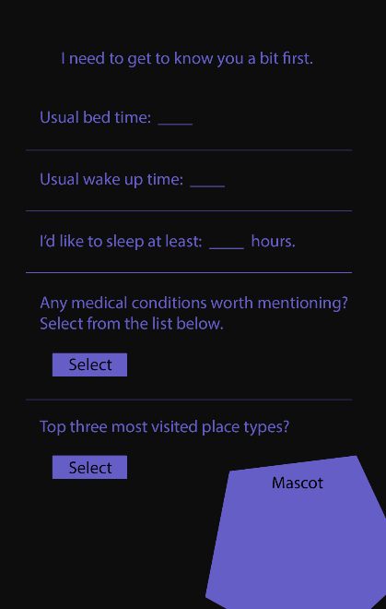

# **Appendix 2 – The Mascot**

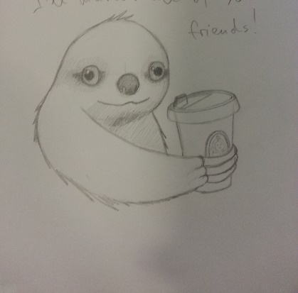 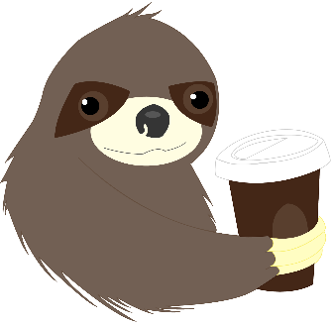 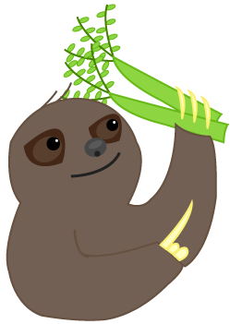

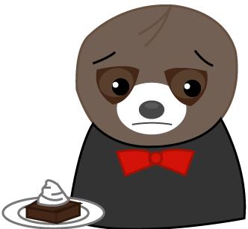 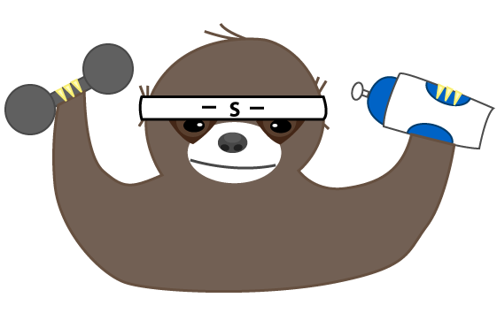 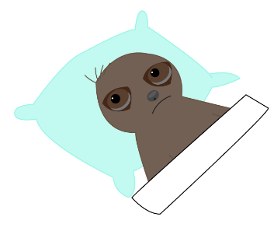

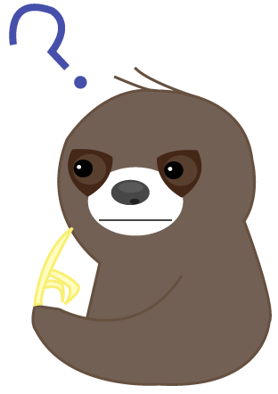 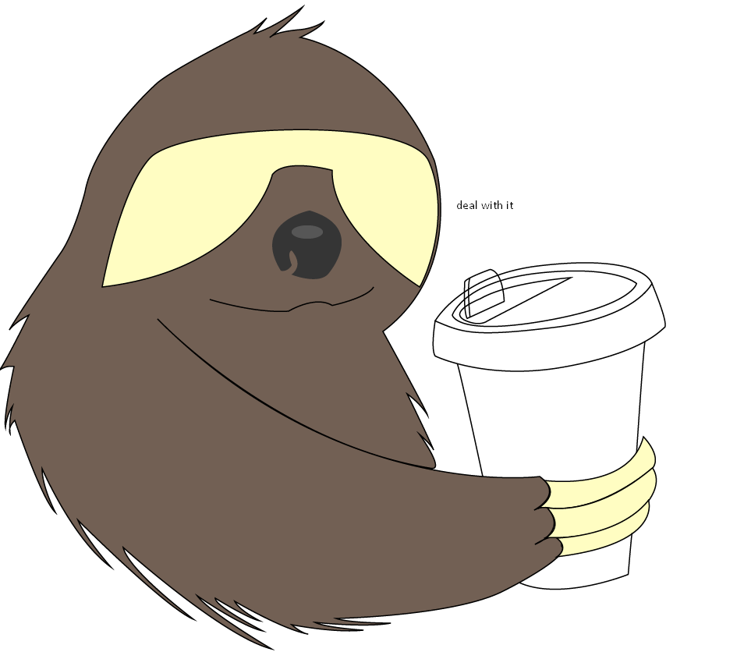

# **Appendix 3 – Final mockups**

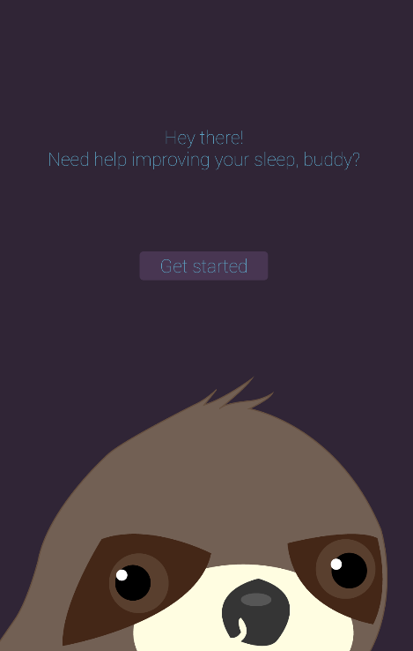 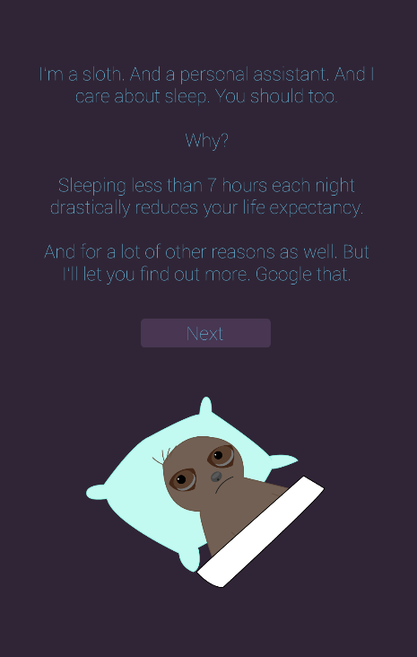 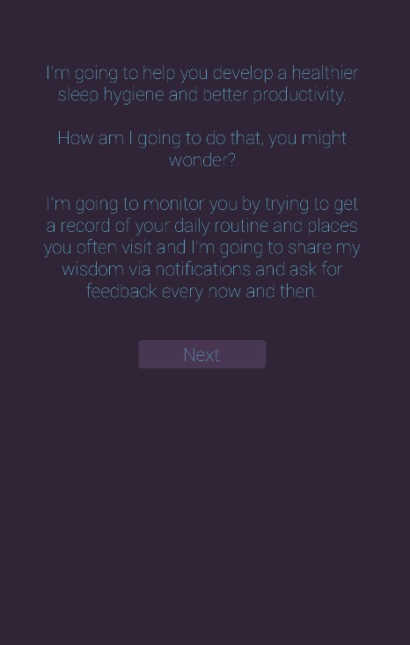

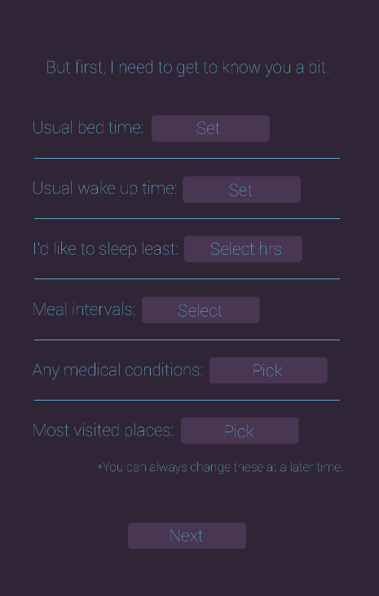 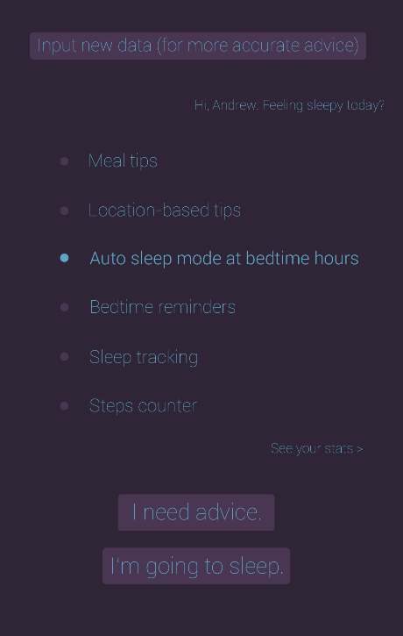 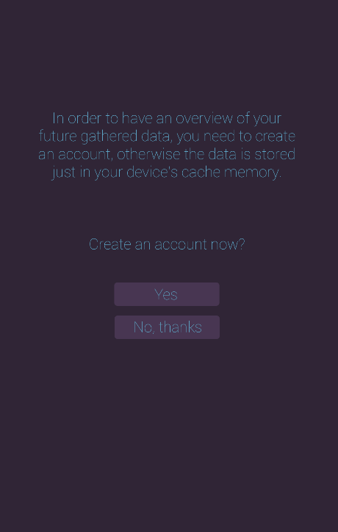

# **Appendix 4 – Sleep routine timelapses (part of field research)**

Marina Stefan

Screen 1: Screen 1:

 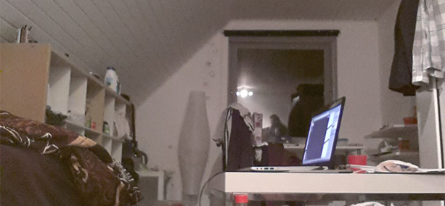

Screen 2: Screen 2:

 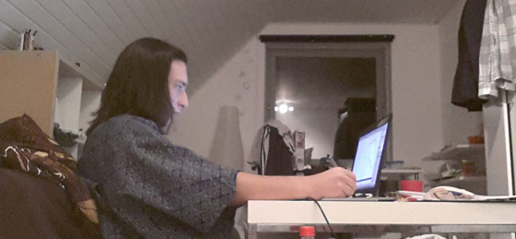

1. NSF’s 2002 “Sleep in America” poll
2. National Sleep Foundation
3. NSF’s 2002 “Sleep in America” poll
4. Knipling and Wang, 1996
5. “Behavioral and pharmacological therapies for late-life insomnia: a randomized controlled trial” 1999 Mar 17;281(11):991-9
6. Special term meanings and more info: http://www.nhs.uk/Conditions/Insomnia/Pages/Treatment.aspx
7. http://www.unifiedremote.com/
8. http://news.bbc.co.uk/2/hi/science/nature/7396356.stm